

KIT (V560DEL)
Catalog Number: CR-M26289
Gene Symbol: C-Kit; CD117; KIT; PBT; SCFR
Description: Anti-KIT (V560DEL) Mouse Monoclonal Antibody

Background: Tyrosine-protein kinase Kit, also known as proto-oncogene c-Kit or CD117 or
Mast/stem cell growth factor receptor (SCFR), is a receptor tyrosine kinase protein that in humans is encoded by the KIT gene. Activating
mutations in this gene are associated
with gastrointestinal stromal tumors, testicular seminoma, mast cell
disease, melanoma, acute myeloid leukemia,
while inactivating mutations are associated with the genetic defect piebaldism.
Immunogen: A synthetic peptide from the internal region of KIT which includes the deletion of V560, human origin.
Tested applications: ELISA, WB, IHC Recommended dilutions:
ELISA: 1:1000-1:5000
WB: 1:500-1:1000
IHC: 1:50-1:100
Concentration: 1 mg/ml
Host: Mouse
Clonality: Monoclonal
Purity: Purified from ascites
Format: Liquid Storage buffer:
Preservative: no
Constituents: PBS (without Mg2+ and Ca2+), pH 7.4, 150 mM NaCl, 50% glycerol
Species Reactivity: Recognizes V560DEL mutant, but not wild-type KIT of vertebrates. Storage Conditions: Store at -20°C. Avoid freeze / thaw cycles.

Western blot:
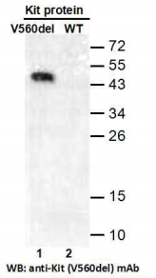
Western blot analysis of recombinant
KIT (V560DEL) and wild-type proteins.
Purified His-tagged KIT (V560DEL) protein
(lane 1) and corresponding wild-type protein
(lane 2) were blotted with anti-KIT (V560DEL) monoclonal antibody (Cat. #26289).

For research use only. Not for diagnostic or therapeutic applications.

Immunofluorescence:
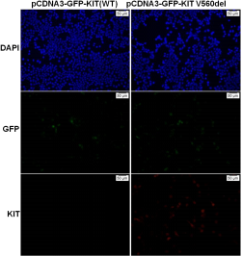
Immunofluorescence of cells expressing KIT proteins with anti-KIT (V560DEL) antibody.
HEK293T cells were transfected with
pCDNA3-GFP-KIT (WT) plasmid (left column) or pCDNA3-GFP-KIT (V560DEL) plasmid
(right column), then fixed and stained with
anti-KIT (V560DEL) monoclonal antibody (Cat.
#26289).

科博瑞（武汉）生物科技有限公司
TEL：027-87615885 15972062685
- mail：3636901710@qq.com
Web:www.coburybio.com

